44.4: a) 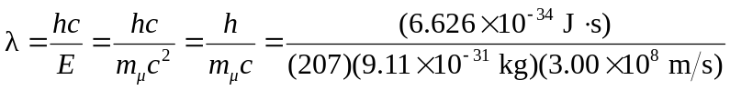
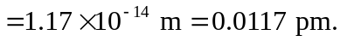
In this case, the muons are created at rest (no kinetic energy). b) Shorter wavelengths would mean higher photon energy, and the muons would be created with non-zero kinetic energy.

